Reopen a Project

The Reopen Project functionality allows users to reactivate a previously closed project. When a project is reopened:
- All previous data is restored, allowing further modifications.
- The reopen date and additional amount are recorded.
- A history log is maintained for tracking past reopen actions.

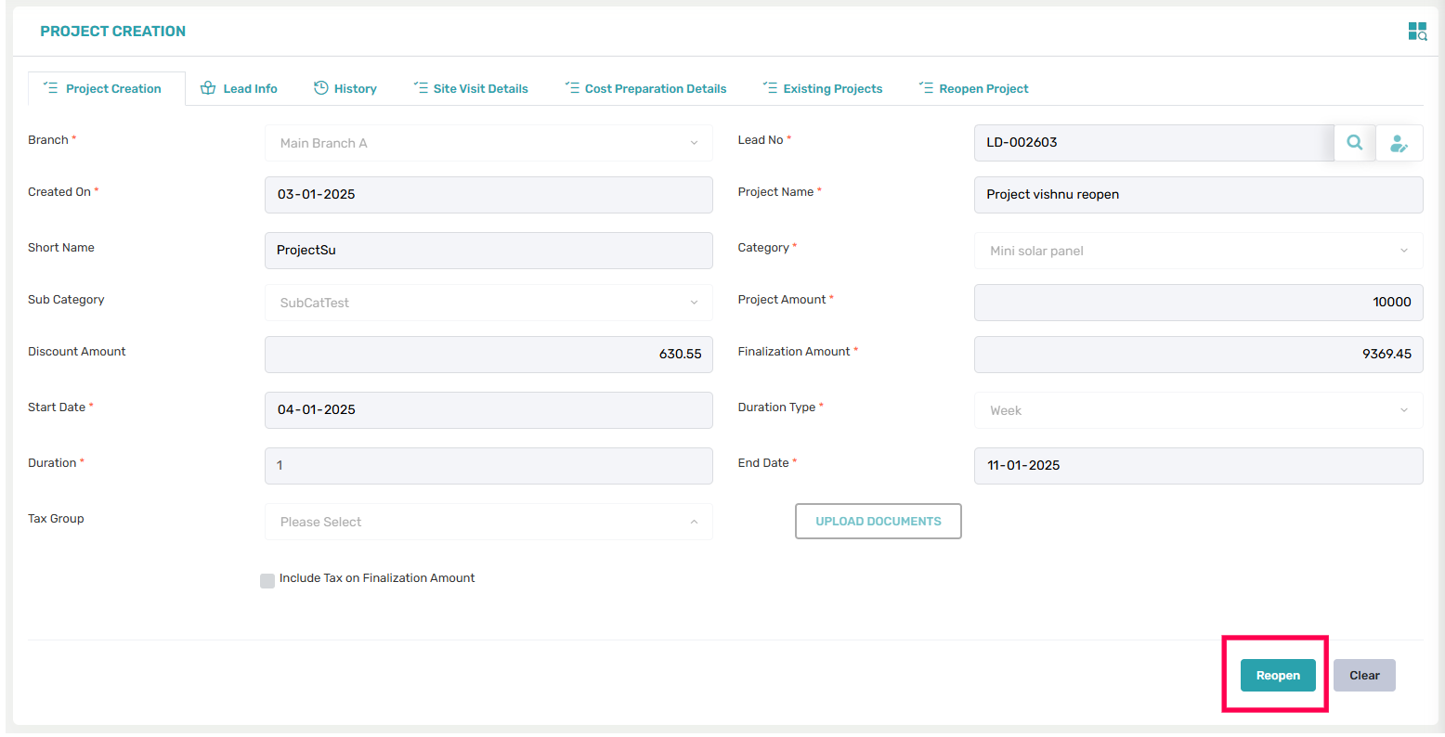
a new 'Reopen' button on the Project Creation Page to allow users to reopen a previously closed project.
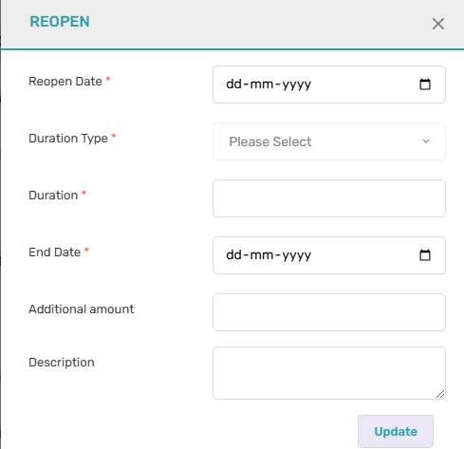

On clicking this page, a popup section appears displaying the following fields: Reopen Date, Period Type, Period, End Date (auto-calculated and editable, similar to the Project Creation page), Amount, and Description.
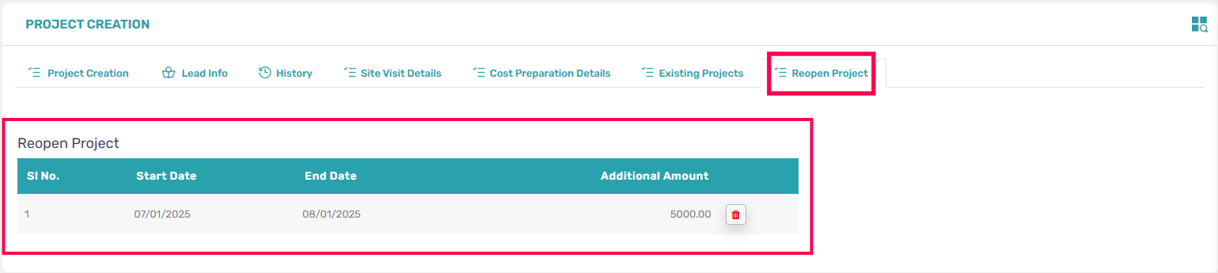
In the Project Creation Page, a history section displayed only if the project has been reopened.
The history presented in a tab Reopen in a grid format with the following details:
- Reopened Date
- Close Date
- Additional Amount
Note:
Changed made in Pages:
- Project wise stage: Project pop up added two new field ‘Reopen date and reopen finish date’ if the project is reopened. Reopen date and finish reopen date is used for checking the project stage creation date and completion date.
Project wise Stage page, during the calculation of the amount, the reopened amount is added to the finalization amount of the project.

- Project follow up page: Project pop up added two new field ‘Reopen date and reopen finish date’.

- Project billing: Added project ‘Reopen amount’. ‘Reopen Date’ added to pop up.

- Project profile report: Profit calculation time if project is reopened and give reopen amount then it’s also added with the profit calculation.

- On the Project Creation page, when viewing a reopened project, the finalization amount remains unchanged. In the Reopen tab, a list of reopened amounts is displayed. The additional amount should be added to the project finalization amount.

Project Wise Stages Restriction on Reopen:
- When a project is reopened, users cannot add work percentage in the Project Wise Stages.
- If work percentage updates are needed for a reopened project, this should be handled as a new requirement.
Automatic Follow-up on Reopen:
- When a project is reopened, the follow-up section is automatically activated.
- This ensures that reopened projects are properly tracked and managed.

Existing projects.
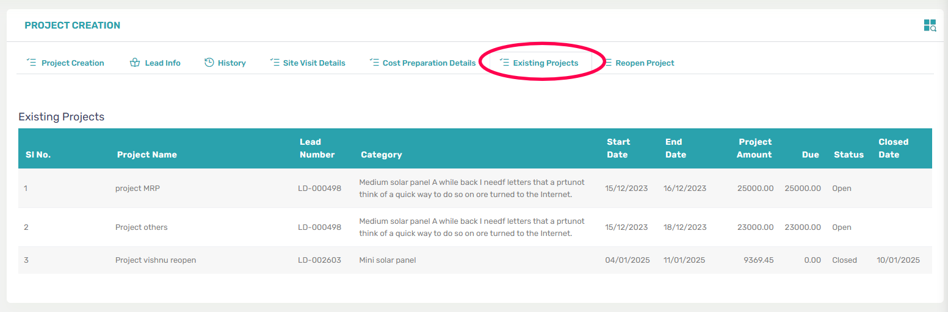
- When a user creates a new project, they can select an existing customer.
- If the selected customer already has existing projects, the system provides an option to view all ongoing/open projects for that customer.
- This helps the user avoid duplicate projects and ensures better project tracking.
Note: Due amount is loaded based on stage wise due and EMI due.

Warning Message for Existing Open Projects with the Same Category.

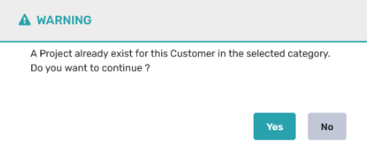

- When a user creates a new project and selects a customer, the system checks if an open project already exists under the same project category for that customer.
- If an existing open project is found, a warning message will appear.

