Lead Management System is a part of the Enterprise Resource Planning (ERP) software used to capture, track, and manage potential customers (leads) through the sales pipeline. It aims to improve sales efficiency and increase conversion rates.

1: App Overview & Key Features
Suggested Talking Points:
- User-Friendly Interface – Modern, intuitive design
- Secure Login – OTP and MPIN verification
- Permissions – Location tracking, contacts, storage
- Lead Management – Generate, track, and follow up on leads
- Reporting – Create and filter lead reports with ease

2: Permissions & Login Flow
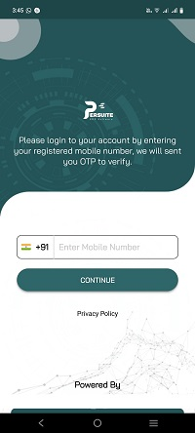
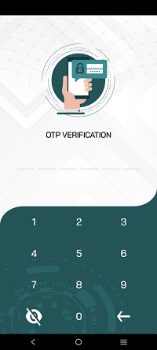

- Permissions Screen – Explains why location, contacts, and storage access are needed
- Login & OTP Verification – Mobile number login plus OTP to verify identity
- Set MPIN – Users create a quick-access PIN for future logins
Key Benefits:
- Enhances security (OTP + MPIN)
- Reduces repeated logins
- Ensures compliance with data privacy

3: Main Dashboard
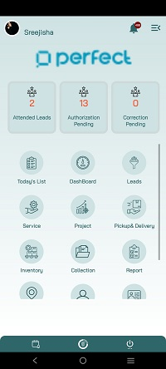

Highlights:
- Counters: Attended Leads, Pending Authorizations, Corrections, etc.
- Modules: Today’s List, Dashboard, Leads, Service, Project, Pickup & Delivery, Inventory, Collection, Report on the basis menu access
- Quick access to essential functions in one place

4: Generating Leads (Detailed)
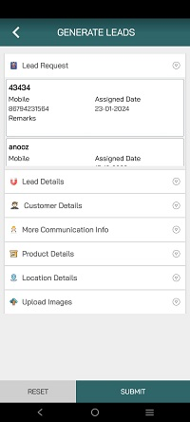

Expandable Sections:
- Lead Details – Basic info like lead source, lead date
- Customer Details – Name, phone, WhatsApp, email, company/contact person
- More Communication Info – House name, place, pincode, address details
- Product Details – Product/service of interest
- Location Details – Capture location data or address
- Upload Images – Attach photos or relevant documents
Key Benefit: Offers a thorough, step-by-step lead entry process for complete records.

5: Quick Lead

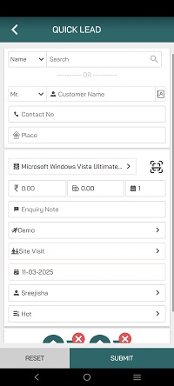

Purpose:
- Rapid data entry for new leads
- Minimal fields: Customer name, contact info, product, date, etc.
- Perfect for fast-paced environments or walk-ins

6: Walk-In Customer
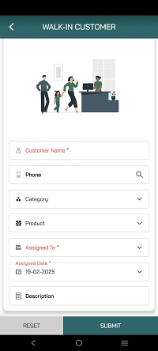

Highlights:
- Fields: Customer Name, Phone, Category, Product, Assigned To, Assigned Date, Description
- Simplified interface for front-desk or showroom scenarios
- Immediately capture customer interest on arrival
Managing walk-in customers in an ERP (Enterprise Resource Planning) system involves capturing, tracking, and servicing customers who physically visit a business location. Once a walk-in customer is assigned, the designated employee will receive a notification. In the walkin customer module, only employees from the sales and marketing departments are listed.
When a walk-in customer is assigned to an employee, the employee receives a push notification. The assigned walk-in customer will appear as a lead request on the lead management page.

7: Lead Management Overview
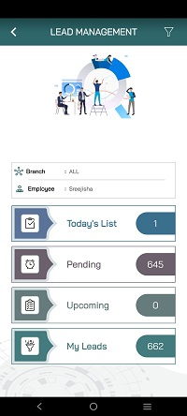

- Filters: Branch (All), Employee (ALL)
- Status Blocks: Today’s List, Pending, Upcoming, My Leads

Key Points:
- Central hub to view and sort leads by status or date
- Helps users prioritize tasks (e.g., pending leads, upcoming tasks)
In Lead Management, assigned leads will be categorized into today's list, pending, or upcoming based on the action date. In My Leads, the list will show leads generated by the logged-in user. In Lead Request, it will display walk-in customers assigned to the user.

7.2: Detailed Lead Management

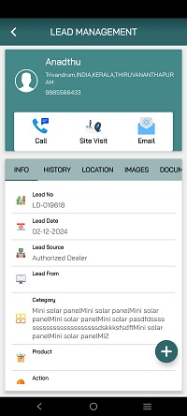

Tabs:
- Info – Lead number, date, source, category, product, next action
- History – Past interactions or status changes
- Location – Address or site visit details
- Images / Documents – Attachments or photos
- Action buttons (Call, Site Visit, Email)
Key Points:
- Everything about a lead in one screen
- Easy to update or attach files

7.3: Follow-Up Details
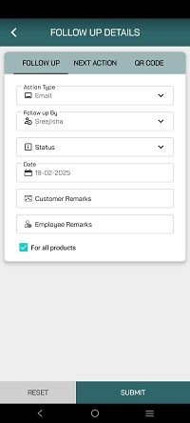

Fields:
- Action Type (Call, Email, Visit, etc.)
- Follow-up By (Employee name)
- Status (e.g., Completed, Pending)
- Date
- Customer & Employee Remarks
- “For all products” checkbox
Advantage:
- Standardizes the follow-up process
- Ensures no lead goes without proper follow-up

8: Lead Report
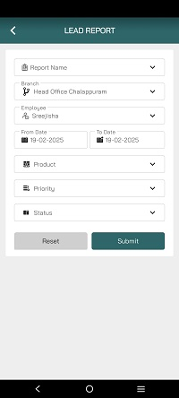

Filters:
- Report Name
- Branch, Employee
- Date Range
- Product, Priority, Status
Report Type
- Follow Up Type
- New List
- Lead Summary

